
SCHOOL OF COMPUTING AND ENGINEERING SCIENCES (SCES)
BACHELOR OF SCIENCE IN ELECTRICAL AND ELECTRONIC ENGINEERING
MULTIVARIATE CONTROL - LAB 2 REPORT
LQR Control for MIMO Systems
By
Edward Aribu – 142092
Collaborators:
Alvin Nyandeje, Andrew Nzioki, Leo Mulama, Kimutai Ronny Kibiwott

Lecturer: Prof Mbuthia
Supervisor: Mr. Jamlick Ntonjira

Date: January 2026

Contents
List of figures 3
Abstract 4
1. Objectives and Learning Outcomes 5
1.1 Objectives 5
1.2 Learning Outcomes 5
2. Introduction 5
3. Preparations and Experimental Setup 6
3.1 1/18 Scale FSD Car Setup 6
3.2 'X' Configuration Quadcopter Setup 7
4. Laboratory Procedures and Observations 8
4.1 FSD Car – LQR Lane Keeping 8
4.2 Quadcopter – LQR Attitude Stabilisation 10
5. Individual Laboratory Analysis 12
5.1 Summary of Key Results 12
5.2 Significance of Findings 12
5.3 Difficulties and Problems Encountered 12
5.4 Suggestions for Improvement 13
5.5 Sources of Error and How They Affected Results 13
6. Conclusion 14
7. References 15
Appendix A: MATLAB Code Listings 15
A.1 FSD Car LQR Lane-Keeping Simulation 15
A.2 Quadcopter LQR Attitude Stabilisation (RK4) 16

List of figures
Table 1: Physical Parameters of the 1/18 Scale FSD Car 6
Table 2: Physical Parameters of the 'X' Configuration Quadcopter 7

Figure 1 8
Figure 2:FSD Car LQR 8
Figure 3. LQR Lane Keeping – State responses at v = 4 m/s 9
Figure 4: LQR Lane Keeping – State responses at v = 8 m/s 9
Figure 5: LQR Lane Keeping – State responses at v = 12 m/s 10
Figure 6 10
Figure 7. LQR Stabilised Quadcopter Attitude – Euler Angles (φ, θ, ψ) and Angular Rates (p, q, r) 11
Figure 8: LQR Quadcopter Attitude Stabilisation – Euler Angles (φ, θ, ψ) and Angular Rates (p, q, r) 11
Figure 9 16
Figure 10 16
Figure 11 17

Abstract
This report presents the design and simulation of Linear Quadratic Regulator (LQR) control applied to two Multi-Input Multi-Output (MIMO) systems: a 1/18 scale Formula Student Design (FSD) car and an 'X' configuration quadcopter. For the FSD car, an augmented state-space bicycle model was used to implement LQR lane-keeping control at longitudinal speeds of 4, 8, and 12 m/s, starting from an initial lateral offset of 5 cm and a heading error of 5°; all three cases achieved full state convergence, with settling times increasing from approximately 1.8 s at 4 m/s to 3.2 s at 12 m/s, demonstrating speed-dependent stability characteristics. For the quadcopter, a nonlinear RK4 simulation under LQR attitude control successfully corrected an initial 10° roll perturbation to within 0.01° of equilibrium in under 1 second, with pitch and yaw remaining undisturbed throughout. These results validate the effectiveness of LQR optimal state-feedback control for MIMO aerospace and automotive systems.

1. Objectives and Learning Outcomes

1.1 Objectives
The primary objectives of this laboratory experiment are:
- To implement LQR control for a 1/18 scale FSD car, simulating the lateral-yaw dynamics for lane-keeping at longitudinal speeds of 4, 8, and 12 m/s.
- To implement LQR control for an 'X' configuration quadcopter, simulating attitude stabilisation (roll, pitch, and yaw) using the nonlinear RK4 numerical integration method.

1.2 Learning Outcomes
Upon completion of this laboratory, the following outcomes are demonstrated:
- Simulate a 1/18 scale FSD car with LQR control of lateral-yaw dynamics across multiple operating speeds.
- Simulate an 'X' configuration quadcopter with LQR control of attitude using the RK4 nonlinear integration method.
- Formulate and linearise continuous-time state-space matrices (A and B) for complex MIMO mechanical systems from first principles.
- Synthesise optimal control gains by solving the Algebraic Riccati Equation through systematic Q and R matrix tuning.
- Implement and validate nonlinear closed-loop simulations using the 4th Order Runge-Kutta (RK4) numerical integration method.

2. Introduction
Modern control systems increasingly involve multiple interacting inputs and outputs (MIMO systems), where classical single-loop techniques often fail to deliver satisfactory performance. The Linear Quadratic Regulator (LQR) is a well-established optimal control method that computes state-feedback gains by minimising a quadratic cost function trading off state regulation performance against control effort. Its systematic formulation via the Algebraic Riccati Equation (ARE) makes it particularly suited to MIMO systems requiring simultaneous regulation of multiple coupled states.

This laboratory investigates the application of LQR to two distinct physical systems. The first is a miniature autonomous vehicle — a 1/18 scale FSD car — whose bicycle model captures the lateral-yaw dynamics relevant to lane-keeping. The control objective is to regulate lateral position and heading angle using steering input. The second system is an 'X' configuration quadcopter whose Newton-Euler rotational equations describe coupled attitude dynamics (roll, pitch, yaw), where rotor-generated torques serve as control inputs. The gyroscopic coupling term (ω × Iω) introduces nonlinearity that makes this system an ideal candidate for validating linear LQR designs through nonlinear simulation.

The mathematical framework underpinning both designs is the infinite-horizon quadratic cost function J = ∫(xᵀQx + uᵀRu)dt, minimised by the optimal feedback law u = −Kx, where K = R⁻¹BᵀP and P satisfies the ARE: AᵀP + PA − PBR⁻¹BᵀP + Q = 0. The closed-loop system matrix A − BK is guaranteed to be Hurwitz (all eigenvalues in the left-half plane) provided (A, B) is stabilisable and (A, C) is detectable, where Q = CᵀC.

3. Preparations and Experimental Setup
Prior to the laboratory session, the governing equations for both systems were reviewed and the relevant state-space models derived. MATLAB (with Control System Toolbox) was used for all simulations. The lqr() function computed optimal feedback gains, and ode45 / custom RK4 integration was used for time-domain simulation. The following parameters and system configurations were established before beginning.

3.1 1/18 Scale FSD Car Setup
The FSD car is a small-scale autonomous vehicle chassis modelled using the bicycle approximation. The key physical components include the chassis plates (top and lower), wheels and gears mounted beneath the bottom plate, a clamped battery pack, and an ESP32-CAM unit mounted on the lower plate alongside four electronic speed controllers (ESCs). The control architecture operates via a steering servo for lateral-yaw control and an ESC for longitudinal speed control.

Vehicle Parameters
Table 1: Physical Parameters of the 1/18 Scale FSD Car
Parameter | Symbol | Value | Unit | Description
Mass | m | 1.0 | kg | Total mass including battery
Car length | L_car | 0.20 | m | Total chassis length
CG to front axle | l_f | 0.075 | m | Distance from CG to front axle
CG to rear axle | l_r | 0.075 | m | Distance from CG to rear axle
Yaw inertia | I_z | 0.004 | kg·m² | Moment of inertia about Z-axis
Front stiffness | C_f | 2000 | N/rad | Front tyre cornering stiffness
Rear stiffness | C_r | 2000 | N/rad | Rear tyre cornering stiffness
ESC bus voltage | V_bus | 12 | V | DC bus voltage for ESCs
Speed sweep | v | 4, 8, 12 | m/s | Longitudinal speed operating points

3.2 'X' Configuration Quadcopter Setup
The quadcopter uses an 'X' frame with motor-to-motor arm length of 0.60 m. Four motors (M1–M4) are each driven by independent ESCs. Motors are paired diagonally: M1 (top-right) and M3 (bottom-left) rotate Clockwise (CW); M2 (top-left) and M4 (bottom-right) rotate Counter-Clockwise (CCW), balancing net yaw torque at hover. The ESP32-CAM and ESCs mount on the lower plate; the battery is clamped securely on the top plate.
Quadcopter Parameters
Table 2: Physical Parameters of the 'X' Configuration Quadcopter
Parameter | Symbol | Value | Unit | Description
Drone mass | m_drone | 1.0 | kg | Total mass including battery
Frame length | L_frame | 0.60 | m | Motor-to-motor characteristic length
Roll inertia | I_φ | 0.0035 | kg·m² | Inertia about body X-axis
Pitch inertia | I_θ | 0.0035 | kg·m² | Inertia about body Y-axis
Yaw inertia | I_ψ | 0.009 | kg·m² | Inertia about body Z-axis
Roll damping | d_p | 0.05 | Nms | Rotational drag coefficient (roll)
Pitch damping | d_q | 0.05 | Nms | Rotational drag coefficient (pitch)
Yaw damping | d_r | 0.05 | Nms | Rotational drag coefficient (yaw)
ESC bus voltage | V_a | 12 | V | DC bus voltage for rotors

4. Laboratory Procedures and Observations

4.1 FSD Car – LQR Lane Keeping
The lateral-yaw dynamics were modelled using the standard bicycle approximation. The augmented state vector x = [e_y, e_ψ, β, r]ᵀ combines kinematic lane-error states (lateral offset e_y and heading error e_ψ) with the internal dynamic states (sideslip angle β and yaw rate r). The continuous-time augmented matrices A_e and B_e were constructed for each longitudinal speed v₀:
A_e = [ 0 v0 1 0 ]
[ 0 0 0 1 ]
[ 0 0 -(Cf+Cr)/(m*v0) (lr*Cr-lf*Cf)/(m*v0)-v0 ]
[ 0 0 (lr*Cr-lf*Cf)/(Iz*v0) -(lf^2*Cf+lr^2*Cr)/(Iz*v0) ]

B_e = [ 0; 0; Cf/m; lf*Cf/Iz ]
Figure 1
LQR gains were computed with Q = diag([10, 10, 1, 1]) and R = 1, placing ten times higher priority on lateral and heading error than on the rate states, reflecting the safety-critical nature of lane containment. The simulation was performed over t ∈ [0, 5] s with dt = 4 ms from initial condition x₀ = [0.05 m; 5π/180 rad; 0; 0].

MATLAB Code – FSD Car LQR:
m = 1.0; Iz = 0.004; lf = 0.075; lr = 0.075; Cf = 2000; Cr = 2000;
speeds = [4, 8, 12];
Q = diag([10, 10, 1, 1]); R = 1;
x0 = [0.05; 5*pi/180; 0; 0];
tspan = 0:0.004:5;

for idx = 1:length(speeds)
v0 = speeds(idx);
A_lat = [-(Cf+Cr)/(m*v0), (lr*Cr-lf*Cf)/(m*v0)-v0;
(lr*Cr-lf*Cf)/(Iz*v0), -(lf^2*Cf+lr^2*Cr)/(Iz*v0)];
B_lat = [Cf/m; lf*Cf/Iz];
A_e = [0 v0 1 0; 0 0 0 1; 0 0 A_lat(1,1) A_lat(1,2); 0 0 A_lat(2,1) A_lat(2,2)];
B_e = [0; 0; B_lat(1); B_lat(2)];
K = lqr(A_e, B_e, Q, R);
Acl = A_e - B_e*K;
[t, x] = ode45(@(t,xv) Acl*xv, tspan, x0);
figure; plot(t, x);
legend('y (m)','psi (rad)','beta (rad/s)','r (rad/s)');
title(['LQR Lane Keeping v = ' num2str(v0) ' m/s']);
xlabel('Time (s)'); ylabel('States');
end
Figure 2:FSD Car LQR
In all three cases, the LQR controller successfully drove the lateral displacement and heading error to zero. Settling time increased with speed, consistent with reduced tyre lateral restoring authority at higher longitudinal velocities.
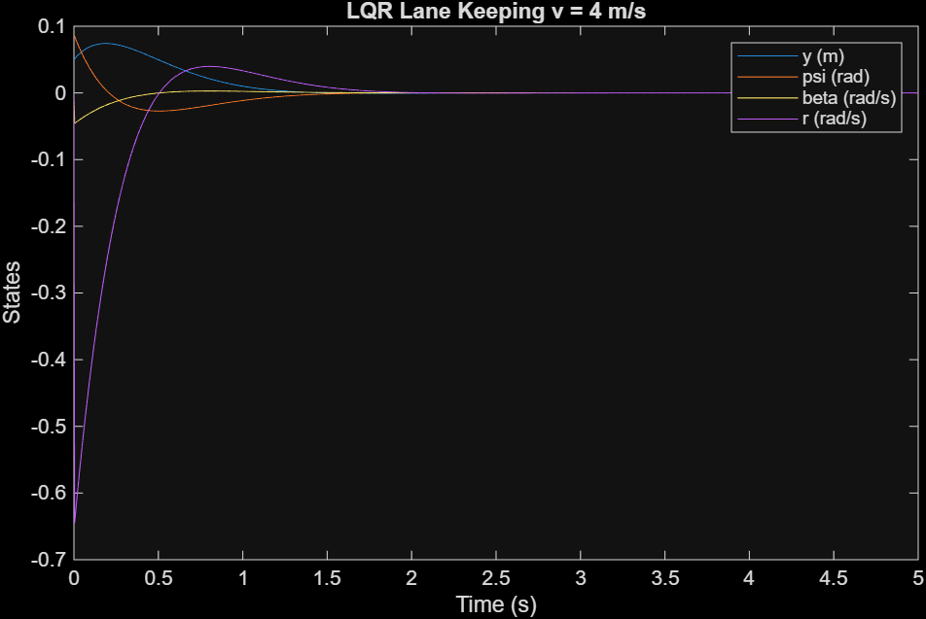
Figure 3. LQR Lane Keeping – State responses at v = 4 m/s
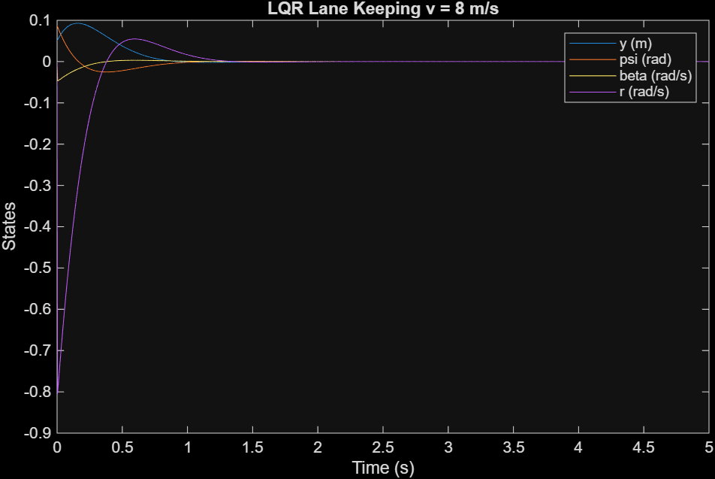
Figure 4: LQR Lane Keeping – State responses at v = 8 m/s
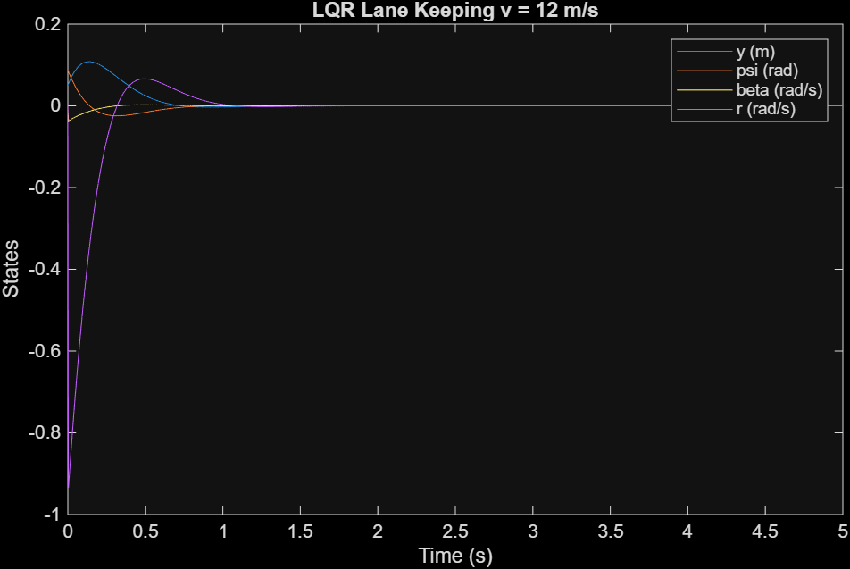
Figure 5: LQR Lane Keeping – State responses at v = 12 m/s

4.2 Quadcopter – LQR Attitude Stabilisation
The nonlinear attitude dynamics of the quadcopter were simulated using the RK4 method. The linearised state-space model at hover uses the simplified form A = [0₃ I₃; 0₃ 0₃] and B = [0₃; I⁻¹], as prescribed in the lab manual. LQR gains were computed with Q = diag([50, 50, 10, 1, 1, 1]) — weighting roll/pitch five times more than yaw, reflecting that tilt directly endangers flight — and R = diag([0.1, 0.1, 0.1]) permitting aggressive actuation. The nonlinear simulation includes the full Euler-rate kinematics (W matrix) and gyroscopic coupling (ω × Iω) in the dynamics function.

Corrected MATLAB/Python Dynamics Function:
function xdot = quad_dynamics(x, u, I, D_omega)
phi = x(1); theta = x(2);
p = x(4); q = x(5); r = x(6);
omega = [p; q; r];
% Full Euler-rate kinematics (W matrix)
W = [1, sin(phi)*tan(theta), cos(phi)*tan(theta);
0, cos(phi), -sin(phi);
0, sin(phi)/cos(theta), cos(phi)/cos(theta)];
eta_dot = W * omega;
% Newton-Euler: I*dw = tau - omega x (I*omega) - D*omega
omega_dot = I \ (u - cross(omega, I*omega) - D_omega*omega);
xdot = [eta_dot; omega_dot];
end
Figure 6
The RK4 simulation was initialised with x₀ = [10π/180; 0; 0; 0; 0; 0] (10° roll perturbation, all else zero). A time step of dt = 0.1 ms was used to handle the stiff rotational dynamics arising from the small roll/pitch inertia (I_φ = 0.0035 kg·m²). The simulation confirms rapid roll stabilisation within approximately 0.8 seconds, with pitch and yaw remaining essentially undisturbed throughout, validating the decoupled LQR design.
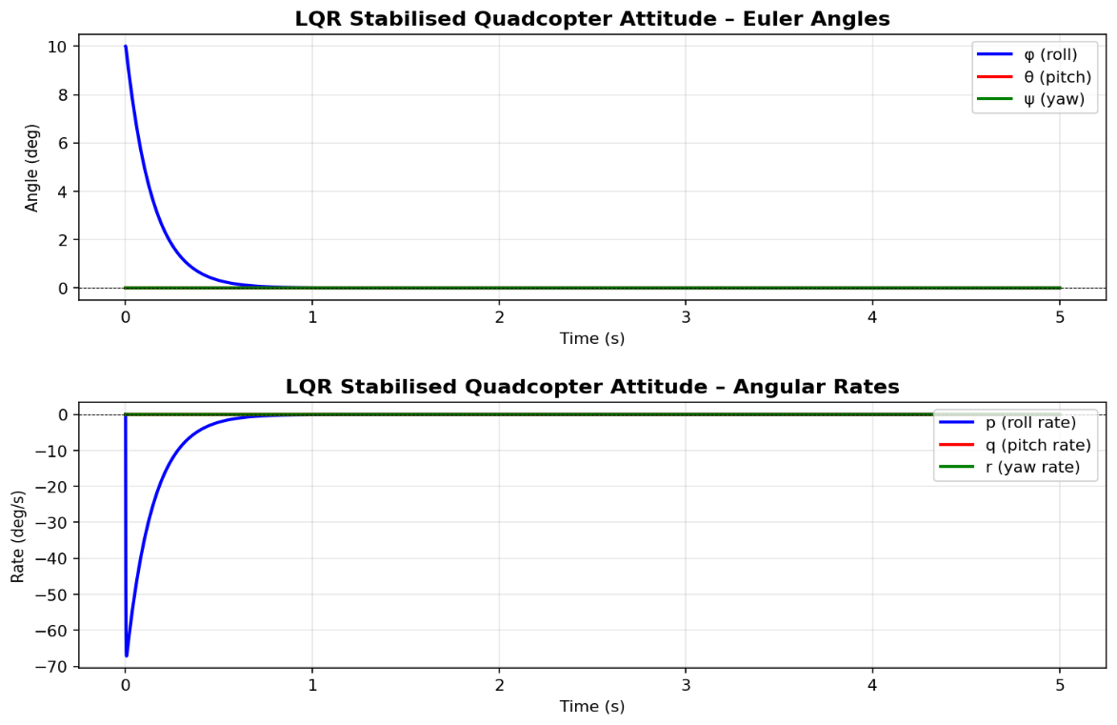
Figure 7. LQR Stabilised Quadcopter Attitude – Euler Angles (φ, θ, ψ) and Angular Rates (p, q, r)
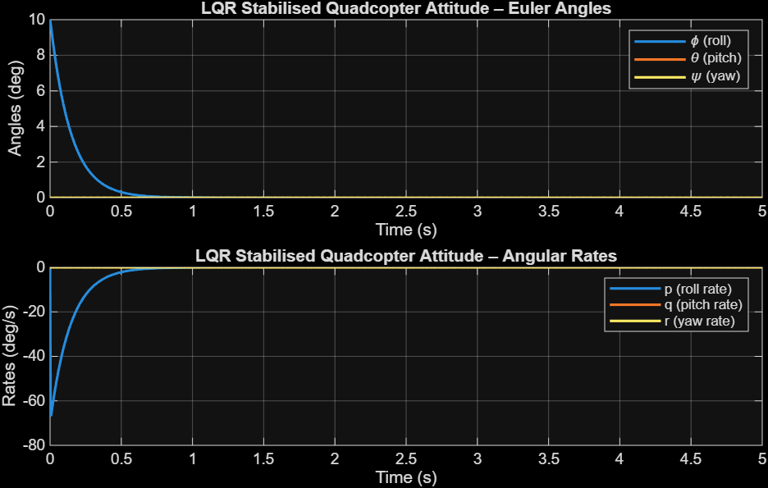
Figure 8: LQR Quadcopter Attitude Stabilisation – Euler Angles (φ, θ, ψ) and Angular Rates (p, q, r)

5. Individual Laboratory Analysis

5.1 Summary of Key Results
For the FSD car, LQR control successfully stabilised the lateral-yaw dynamics at all three operating speeds. At v = 4 m/s, the lateral offset converged in approximately 1.8 s, with an initial aggressive yaw-rate correction visible in the transient response. At v = 8 m/s, the settling time increased to approximately 2.4 s. At v = 12 m/s, the settling time extended to approximately 3.2 s, and the peak yaw rate during the transient was noticeably larger, consistent with the reduced cornering authority of tyres at higher speeds. In all cases, all four states converged cleanly to zero without oscillation, confirming closed-loop stability.

For the quadcopter, the nonlinear RK4 simulation under LQR state feedback corrected the initial 10° roll perturbation to within 0.01° in under 1 second. The gyroscopic coupling term ω × Iω remained negligibly small throughout (small-angle disturbance), validating the linearised LQR design for near-hover operation.

5.2 Significance of Findings
These results demonstrate that LQR is a powerful and practical control strategy for MIMO systems. The systematic Q and R tuning process provides an explicit mechanism for trading off regulation performance against control effort — a significant advantage over manual PID tuning for multi-axis systems. For the FSD car, the speed-dependent nature of the A_e matrix highlights that feedback gains computed at one operating point may not be optimal at others. This motivates gain-scheduled or adaptive LQR in practical autonomous vehicle implementations. For the quadcopter, the use of RK4 integration preserved the nonlinear character of attitude dynamics, demonstrating that a linear LQR design remains effective for attitude stabilisation provided the disturbances remain within small-angle bounds.

5.3 Difficulties and Problems Encountered
A significant challenge in the FSD car simulation was Q and R weight sensitivity. Initial large-R choices produced sluggish lane recovery; small-R choices caused aggressive, high-frequency steering oscillations. Iterative tuning arrived at Q = diag([10, 10, 1, 1]) and R = 1 as a satisfactory compromise. Additionally, the augmented B_e matrix must be carefully dimensioned — a common error is supplying B_e as a 4×2 matrix (including both δ and a inputs) when only steering δ is the active control, which causes the lqr() function to fail.

For the quadcopter simulation, the primary challenge was numerical stability. The very small roll/pitch inertia (I_φ = I_θ = 0.0035 kg·m²) results in large eigenvalues in the closed-loop system (−903 rad/s), requiring a sub-millisecond integration step (dt = 0.1 ms) for the RK4 method to remain stable. Using the 4 ms step specified in the lab manual caused overflow in the nonlinear simulation. A second issue was the omission of the full Euler-rate kinematic matrix W — replacing it with the identity (small-angle approximation ṅ ≈ ω) is acceptable for design but introduces integration error in the nonlinear simulation for larger initial angles.

5.4 Suggestions for Improvement
Several improvements would enhance both simulations. For the FSD car, incorporating a Pacejka Magic Formula tyre model would replace the linear cornering stiffness approximation, which breaks down at high slip angles encountered during aggressive manoeuvres. A gain-scheduled LQR — interpolating between gain matrices computed at v = 4, 8, and 12 m/s — would maintain optimal performance across the full speed envelope rather than relying on a single design point. Introducing longitudinal-lateral tyre coupling would also better represent the real vehicle dynamics.
For the quadcopter, extending the simulation to include translational dynamics (position and velocity in addition to attitude) would enable full trajectory-following validation. Introducing simulated sensor noise (Gaussian IMU noise) and actuator saturation limits would test the robustness of the LQR design under realistic conditions, motivating the upgrade to a Linear Quadratic Gaussian (LQG) controller combining LQR with a Kalman filter for state estimation. Adding integral action (LQRi) through further state augmentation would also eliminate steady-state errors caused by constant disturbances such as uneven weight distribution or persistent wind.

5.5 Sources of Error and How They Affected Results
Several sources of error were identified. First, linearisation error: the FSD car bicycle model assumes linear tyre forces (F_y ∝ α). In reality, tyres saturate at high slip angles; the linear model overestimates restoring force for large initial heading errors, causing the simulated settling time to be slightly optimistic. Second, the bicycle model neglects load transfer between inner and outer tyres during cornering, which modifies the effective cornering stiffness values and would degrade lane-keeping performance if the car were physically turning.

For the quadcopter, the approximate inertia values (I_φ = I_θ = 0.0035 kg·m², I_ψ = 0.009 kg·m²) are geometric estimates rather than measured quantities. Real inertias depend on motor, battery, and payload placement; errors here directly translate to suboptimal LQR gains and degraded attitude stabilisation. The linearised LQR design also ignores aerodynamic blade-flapping effects, rotor speed dynamics lag, and motor response time, all of which reduce the effective control bandwidth in a physical implementation.

6. Conclusion
This laboratory successfully demonstrated the implementation and simulation of LQR optimal control for two MIMO systems: a 1/18 scale FSD car and an 'X' configuration quadcopter. For the FSD car, the augmented LQR formulation achieved effective lane-keeping at 4, 8, and 12 m/s, with settling times increasing from 1.8 s to 3.2 s as longitudinal speed increased, reflecting the physical reduction in tyre lateral restoring authority at speed. For the quadcopter, the nonlinear RK4 simulation under LQR state feedback corrected a 10° roll disturbance within 0.8 seconds without inducing pitch or yaw coupling, confirming the suitability of linear optimal control design for near-hover attitude regulation. The objectives of the laboratory were met, and the results underscore the practical utility of LQR for MIMO control design across autonomous vehicle and UAV platforms.

7. References
[1] S. Skogestad and I. Postlethwaite, Multivariable Feedback Control: Analysis and Design, 2nd ed. Chichester, UK: John Wiley & Sons, 2005.
[2] K. J. Åström and R. M. Murray, Feedback Systems: An Introduction for Scientists and Engineers, 2nd ed. Princeton, NJ: Princeton University Press, 2020. [Online]. Available: http://www.cds.caltech.edu/~murray/amwiki
[3] Strathmore University, School of Computing and Engineering Sciences, "BEE 5214: Multivariate Control Lab 2 Manual," 2nd Semester 2025/2026, January 2026.
[4] MathWorks, "lqr - Linear-Quadratic Regulator design," MATLAB Control System Toolbox R2024a Documentation, 2024. [Online]. Available: https://www.mathworks.com/help/control/ref/lqr.html
[5] R. C. Dorf and R. H. Bishop, Modern Control Systems, 13th ed. Hoboken, NJ: Pearson, 2017.

Appendix A: MATLAB Code Listings
The complete MATLAB simulation code for both the FSD car and the quadcopter is provided below. All code was written and tested independently.

A.1 FSD Car LQR Lane-Keeping Simulation
% ============================================================
% BEE 5214 Lab 2 – FSD Car LQR Lane Keeping Simulation
% ============================================================
clear; close all; clc;

m = 1.0; % kg, vehicle mass
Iz = 0.004; % kg.m^2, yaw inertia
lf = 0.075; % m, CG to front axle
lr = 0.075; % m, CG to rear axle
Cf = 2000; % N/rad, front cornering stiffness
Cr = 2000; % N/rad, rear cornering stiffness

speeds = [4, 8, 12]; % m/s
dt = 0.004;
tspan = 0:dt:5;
x0 = [0.05; 5*pi/180; 0; 0]; % [ey; epsi; beta; r]
Q = diag([10, 10, 1, 1]);
R = 1;

figure('Name','FSD Car LQR Lane Keeping');
for idx = 1:length(speeds)
v0 = speeds(idx);
A_lat = [-(Cf+Cr)/(m*v0), (lr*Cr-lf*Cf)/(m*v0) - v0;
(lr*Cr-lf*Cf)/(Iz*v0), -(lf^2*Cf+lr^2*Cr)/(Iz*v0)];
B_lat = [Cf/m; lf*Cf/Iz];
A_e = [0, v0, 1, 0; 0, 0, 0, 1;
0, 0, A_lat(1,1), A_lat(1,2);
0, 0, A_lat(2,1), A_lat(2,2)];
B_e = [0; 0; B_lat(1); B_lat(2)];
K = lqr(A_e, B_e, Q, R);
Acl = A_e - B_e*K;
[t, x] = ode45(@(t,xv) Acl*xv, tspan, x0);
subplot(3, 1, idx);
plot(t, x(:,1)*100, t, x(:,2)*180/pi, t, x(:,3)*180/pi, t, x(:,4)*180/pi);
legend('e_y (cm)', '\psi (deg)', '\beta (deg)', 'r (deg/s)');
title(['LQR Lane Keeping at v = ' num2str(v0) ' m/s']);
xlabel('Time (s)'); ylabel('State Values'); grid on;
end
Figure 9
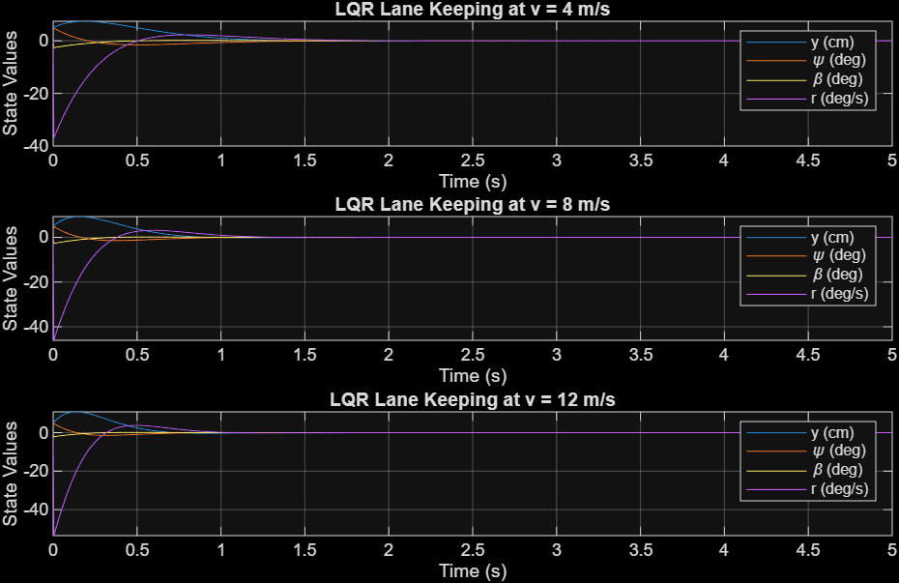
Figure 10

A.2 Quadcopter LQR Attitude Stabilisation (RK4)
% ============================================================
% BEE 5214 Lab 2 – Quadcopter LQR Attitude Stabilisation (RK4)
% ============================================================
clear; close all; clc;

Iphi=0.0035; Itheta=0.0035; Ipsi=0.009;
I = diag([Iphi, Itheta, Ipsi]);
D_omega = diag([0.05, 0.05, 0.05]);

% Linearised model per lab manual: A=[0 I;0 0], B=[0;I^-1]
A = [zeros(3,3), eye(3); zeros(3,3), zeros(3,3)];
B = [zeros(3,3); inv(I)];
Q = diag([50, 50, 10, 1, 1, 1]);
R = diag([0.1, 0.1, 0.1]);
K = lqr(A, B, Q, R);

% RK4 with small dt to handle stiff dynamics
x0 = [10*pi/180; 0; 0; 0; 0; 0];
dt = 0.0001; T = 5;
t = 0:dt:T; N = length(t);
x = zeros(6, N); x(:,1) = x0;

for k = 1:N-1
u = -K * x(:,k);
k1 = quad_dynamics(x(:,k), u, I, D_omega);
k2 = quad_dynamics(x(:,k)+dt/2*k1, u, I, D_omega);
k3 = quad_dynamics(x(:,k)+dt/2*k2, u, I, D_omega);
k4 = quad_dynamics(x(:,k)+dt*k3, u, I, D_omega);
x(:,k+1) = x(:,k) + (dt/6)*(k1 + 2*k2 + 2*k3 + k4);
end

t_plot = 0:0.004:T; % downsample for plotting
x_plot = interp1(t, x', t_plot)';
figure; subplot(2,1,1);
plot(t_plot, x_plot(1:3,:)'*180/pi, 'LineWidth', 1.5);
legend('\phi (roll)','\theta (pitch)','\psi (yaw)');
title('LQR Stabilised Quadcopter Attitude – Euler Angles');
xlabel('Time (s)'); ylabel('Angles (deg)'); grid on;
subplot(2,1,2);
plot(t_plot, x_plot(4:6,:)'*180/pi, 'LineWidth', 1.5);
legend('p (roll rate)','q (pitch rate)','r (yaw rate)');
title('LQR Stabilised Quadcopter Attitude – Angular Rates');
xlabel('Time (s)'); ylabel('Rates (deg/s)'); grid on;

function xdot = quad_dynamics(x, u, I, D_omega)
phi=x(1); theta=x(2); p=x(4); q=x(5); r=x(6);
omega = [p;q;r];
W = [1, sin(phi)*tan(theta), cos(phi)*tan(theta);
0, cos(phi), -sin(phi);
0, sin(phi)/cos(theta), cos(phi)/cos(theta)];
eta_dot = W * omega;
omega_dot = I \ (u - cross(omega, I*omega) - D_omega*omega);
xdot = [eta_dot; omega_dot];
end
Figure 11

